**..........................................**

**Challenge 5**

**..........................................**

**challenge link 🡪**

“ <http://www.pythonchallenge.com/pc/def/peak.html> “

An image is displayed as usual

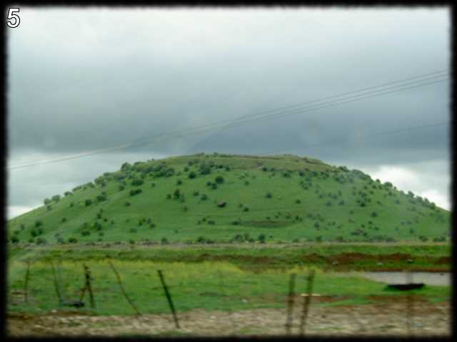

Here the hint is "pronounce it". Firstly, I have no idea what to do and then thought that something should be there in source code to get the challenge.

In source code there was one comment i.e " ***peak hell sounds familiar ?*** "

So, I started pronouncing and checking the URL with different words like hill, mountain, peakhill and so on after few tries, I got it as "pickle"

When you use pickle in URL, we get " ***yes! pickle!*** ".

Then I searched google about pickle and found that there is a module named pickle in python and it is used for object serialisation.

In source code there is " [banner.p](http://www.pythonchallenge.com/pc/def/banner.p) " in which there was bunch of character printed.

I used pickle module in this banner.p and made a program (challenge_05.py) and load out the data from it. I get a very long list. There were lists inside the main list which have tuples. In tuple one was a string and second one was number.

So after printing those I got word formed by "#"

This is the final word which will help you to move to next challenge.